

**CEF 440: INTERNET AND MOBILE PROGRAMMING**

**GROUP MEMBERS:**

|  |  |
| --- | --- |
| **NAME** | **MATRICULE NUMBER** |
| FORMASIT CHIJOH FOKUNAG | FE20A041 |
| GAMUAH PADJINOU RYANE JOY | FE20A044 |
| MOSONGO ADINA SAKWE NANGERI | FE20A066 |
| NDALEGH NOELA LUM MBAH | FE20A070 |
| RACHEAL NKONGHO TAFONGOH | FE20A100 |

**COURSE INSTRUCTOR**

DR NKEMENI VALERY

**Date**: May 26, 2023

**TASK 5**

**UI DESIGN AND IMPLEMENTATION**

**Table of content**

* Introduction
* Definition
* Importance
* Overview of the application
* Project Title
* Programming Language
* Frameworks and Tools
* UI Diagrams: Vendor
* Register
* Login
* Add products
* Homepage
* Update Product
* UI Diagrams: Buyer
* Homepage
* Product Return Page
* Location
* Shop Details

**Introduction**

UI design has a major role in making sure that interfaces help us achieve our goals with ease and enjoyment. For the users, UI designers ensure the visual design of an app or website is visually pleasing and intuitive to navigate.

**Definition**: UI DESIGN is the process designers use to build interfaces in software or computerized devices, focusing on looks or style.

It is likely the first thing you encounter when you use an application or visit a website

**Importance of UI design**

* User interface design can make a difference in a product’s emotional appeal. Done right, UI design can pique your user’s interest and get them excited about exploring the product more.
* Quality UI design is the top reason why a website enjoys high traffic.

**Overview of the application**

* **Project title**: Design and Implementation of a market management system
* **Programming language:** Javascript, React Native for the web app
* Pages were implemented based on system requirements gathered and UML diagrams.

**UI Diagrams: Vendor View**

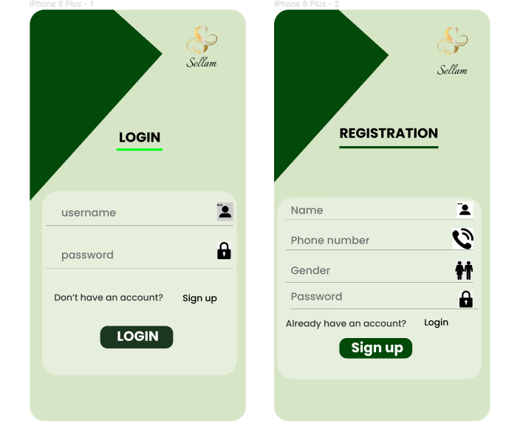

**Logging Page Signup Page**

* **Logging Page:** Only the vendors perform create account and signup function. They enter their username, password during login.
* **Signup Page**: here, the vendor enters his details such as name to be displayed on his home page and used for login purpose too, his phone number, gender, password

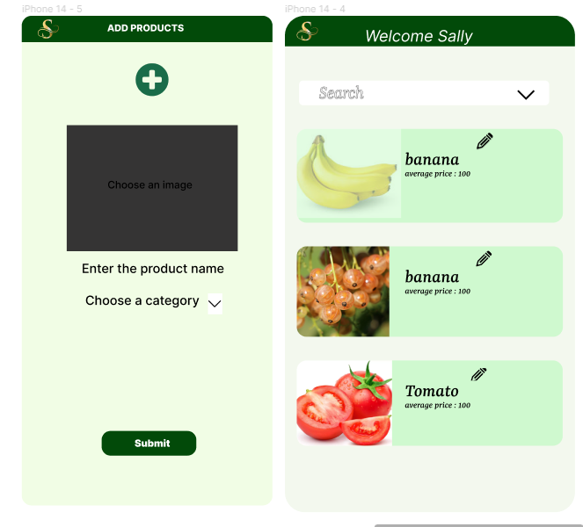

**Add product page Home page for Vendor**

* **Add product page:** This is a page for new vendor to add his products. He can always choose an image from a wide range of available pictures or snap one. Then also identify the category.
* **Home page for Vendor:** home page for vendor to see his products and select edit tag to edit of not

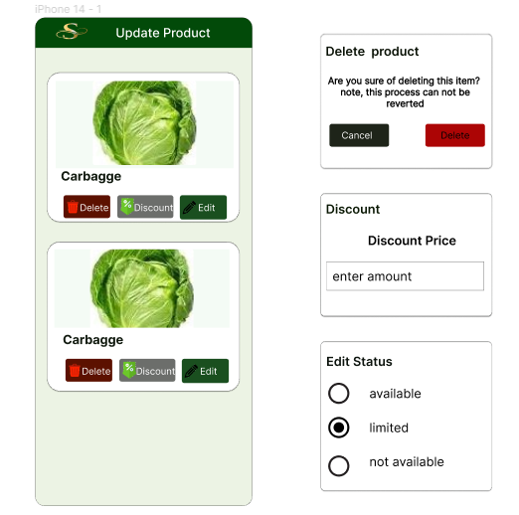

**Update product page**

* This Update product page is to edit the item like delete it, give it a discount or edit the status.

**UI Diagrams: Buyer View**

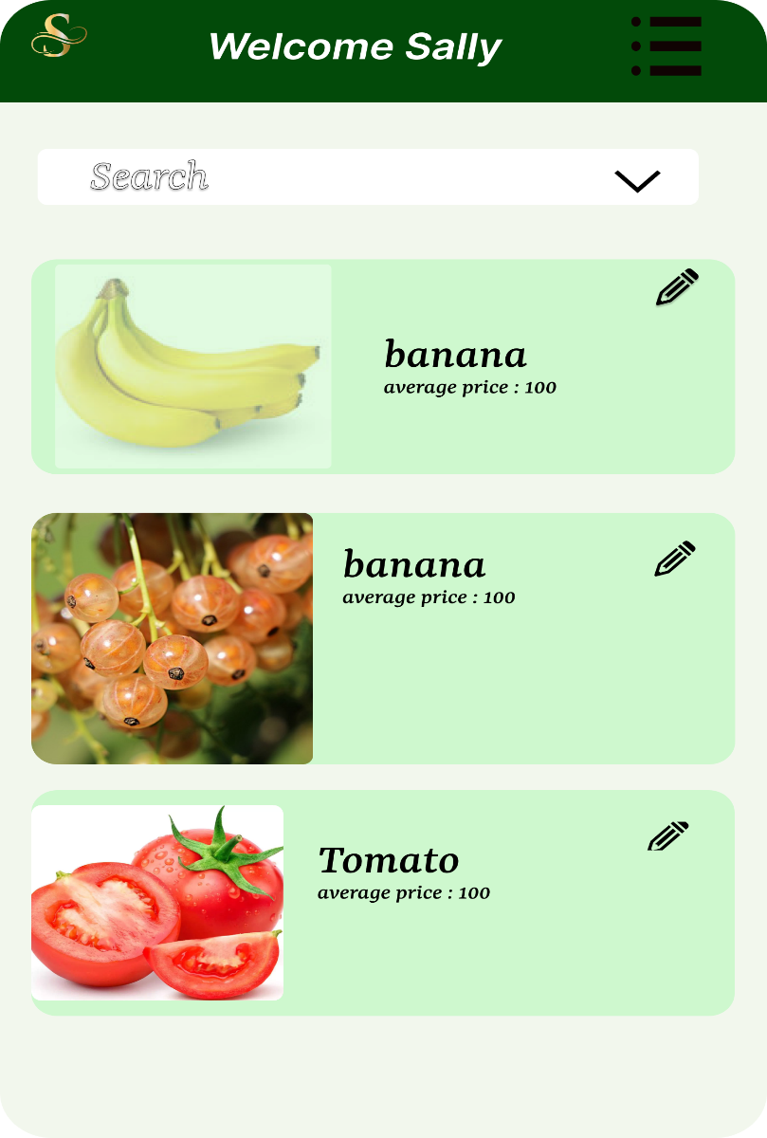

**Homepage for Buyer**

* Here is the landing page, where a buyers view all products available in the markets. Special product search is also possible as is shown.

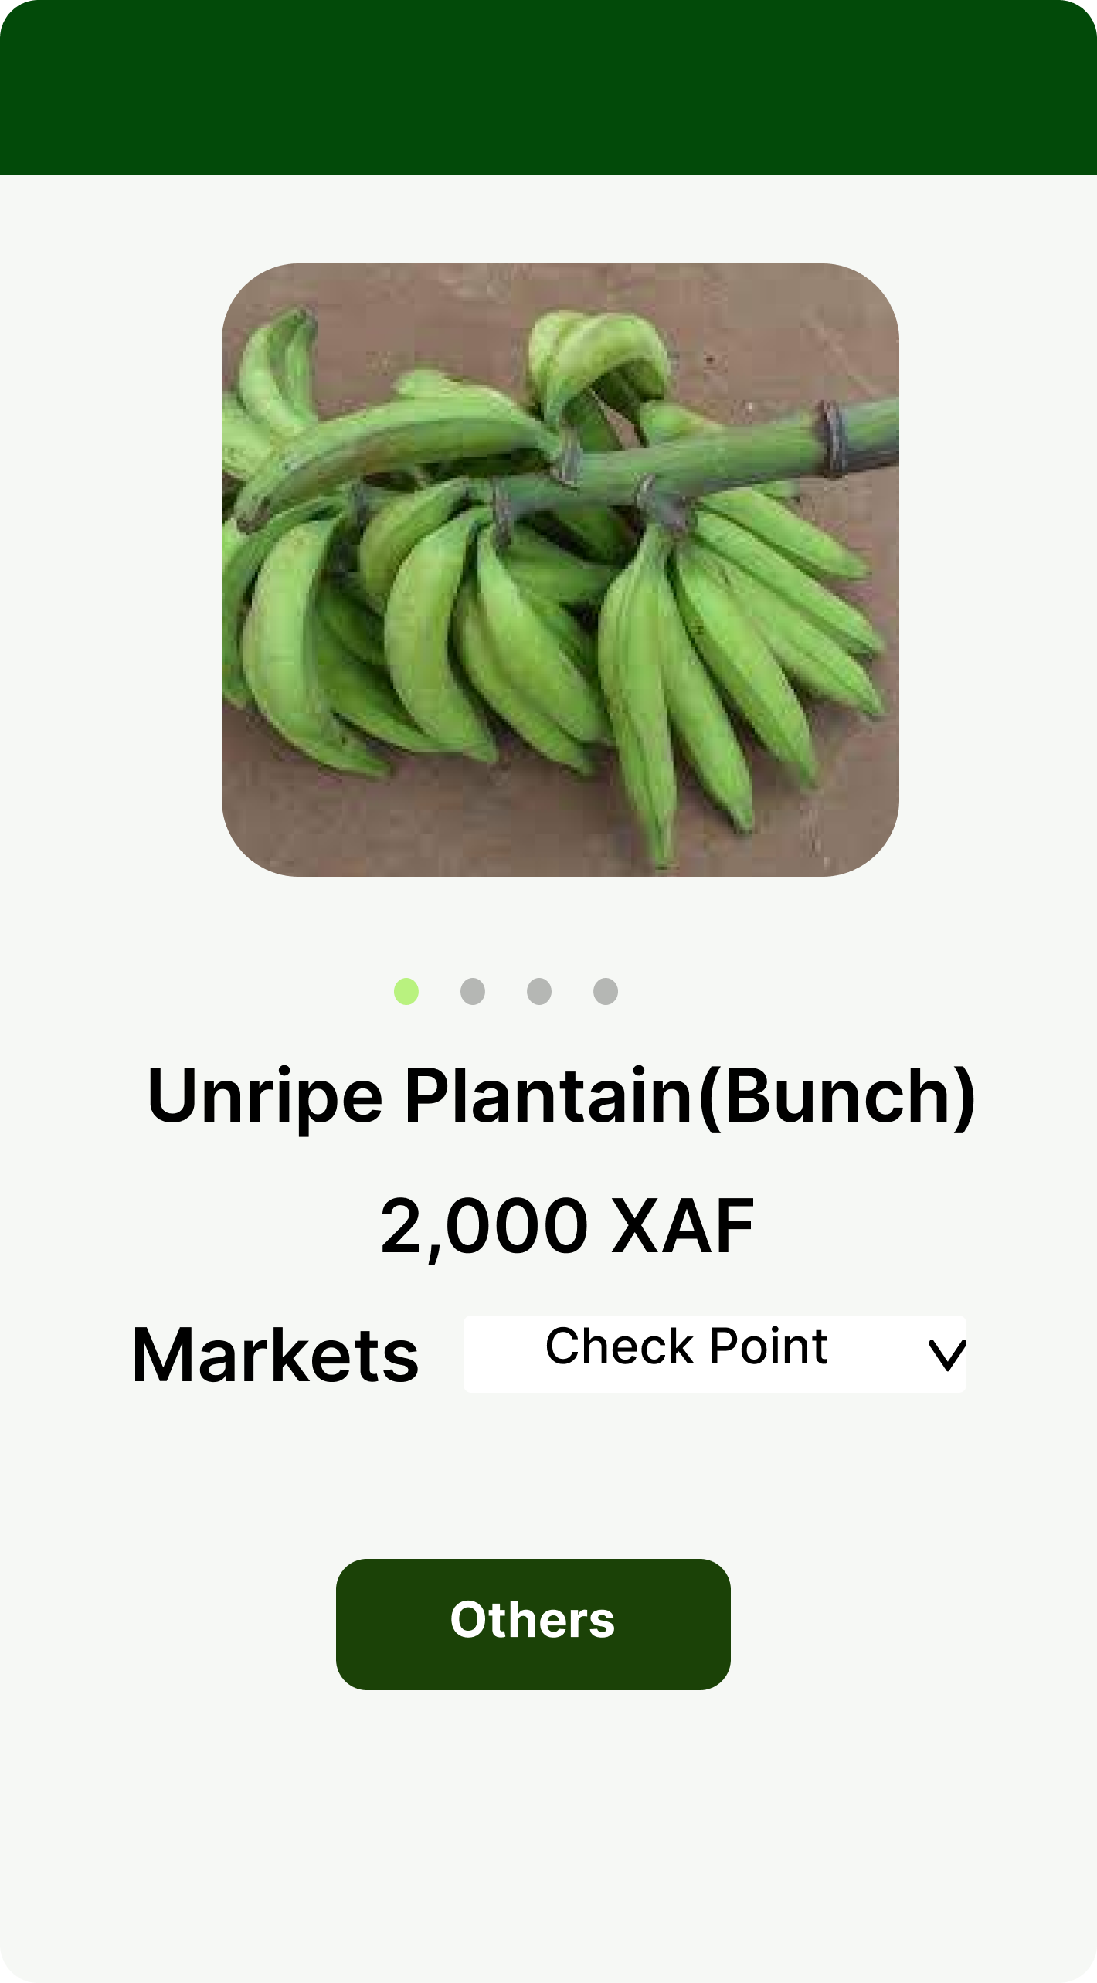

**Product return page**

* This page returns the market details of a product after successful search or selection.

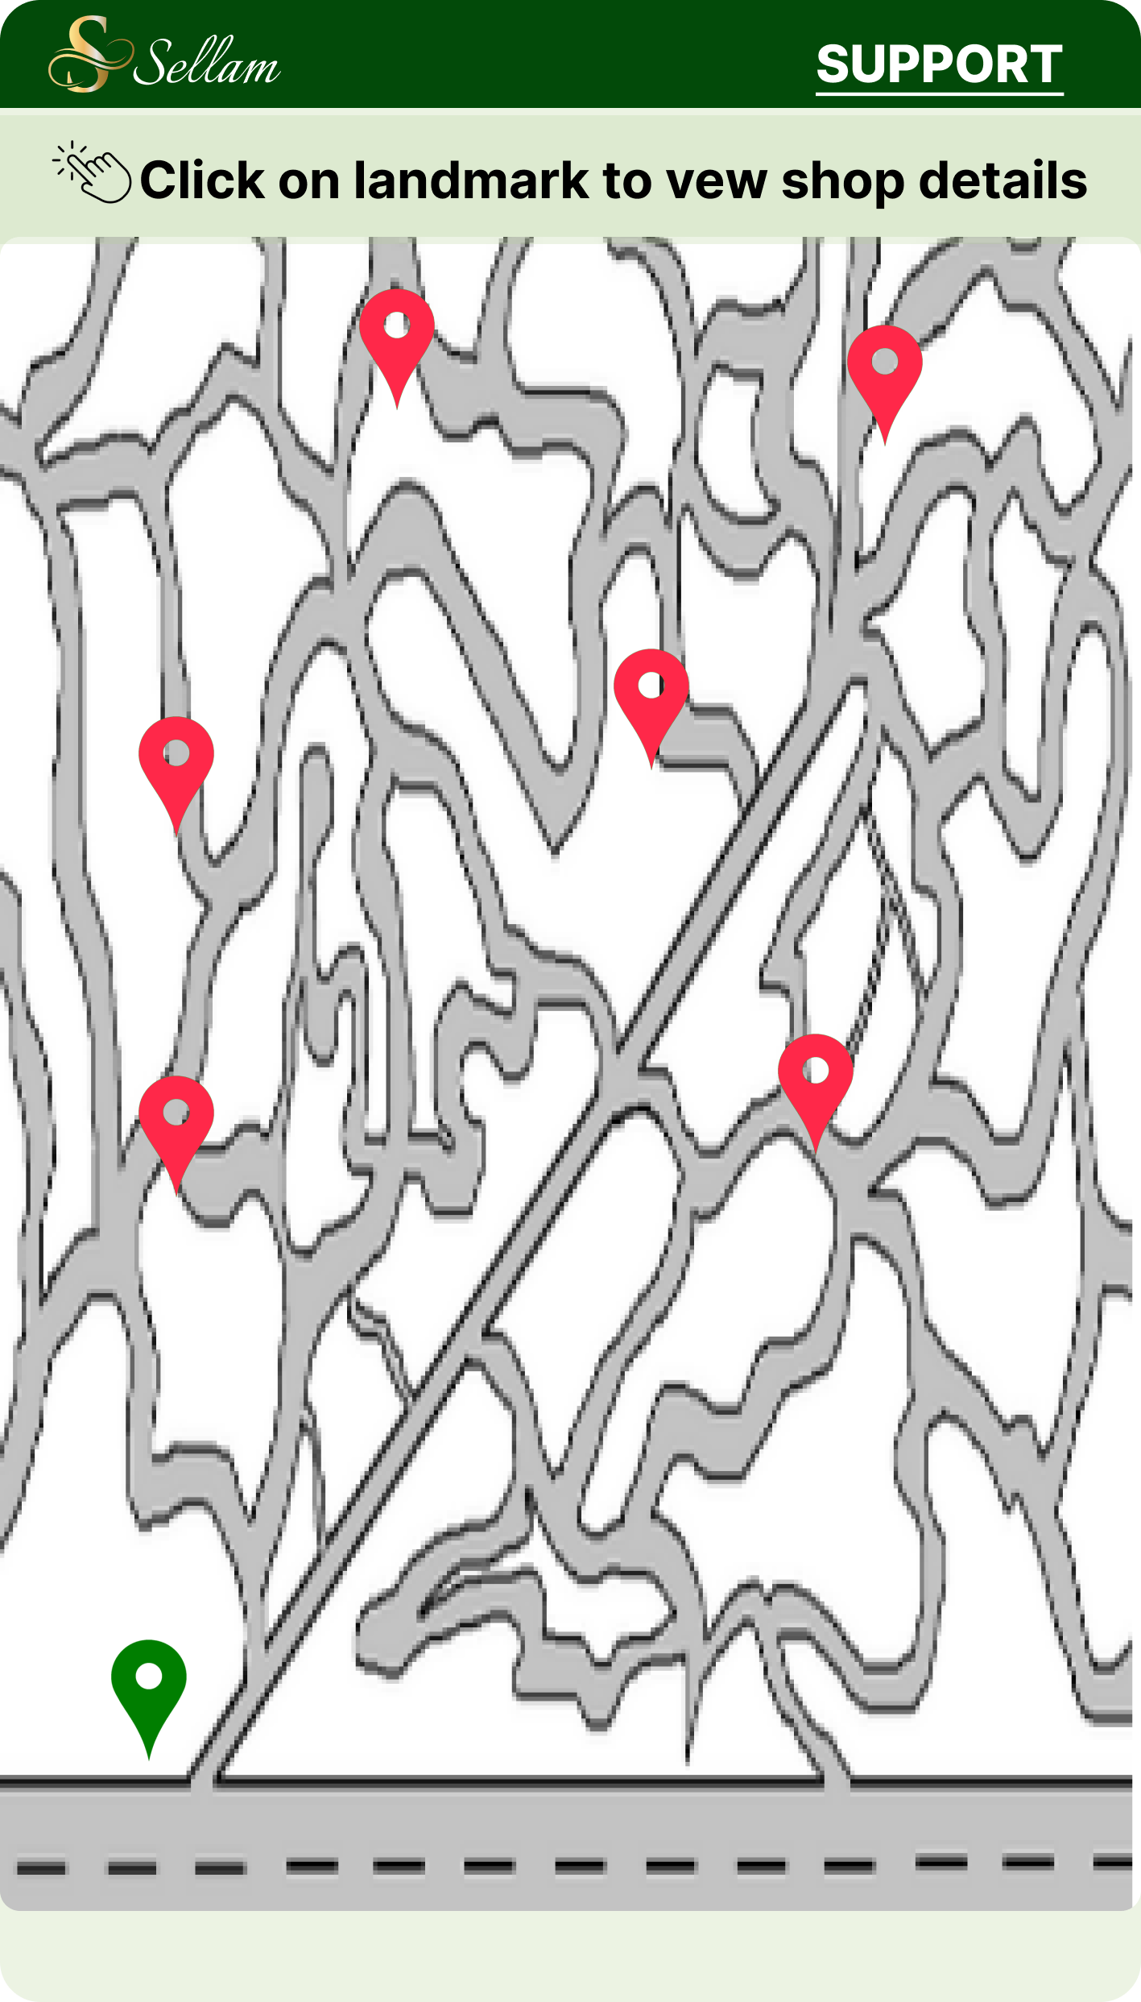

**Location Page**

* On this page is displayed the different locations of stores selling a particular product in a market specified in the preceding page.

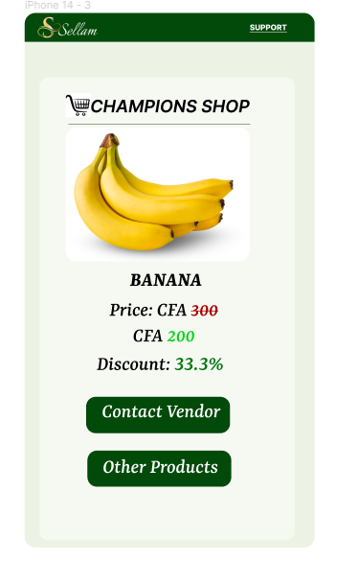

**Shop details**

* For a particular shop selected before, its specific product details and other features are displayed